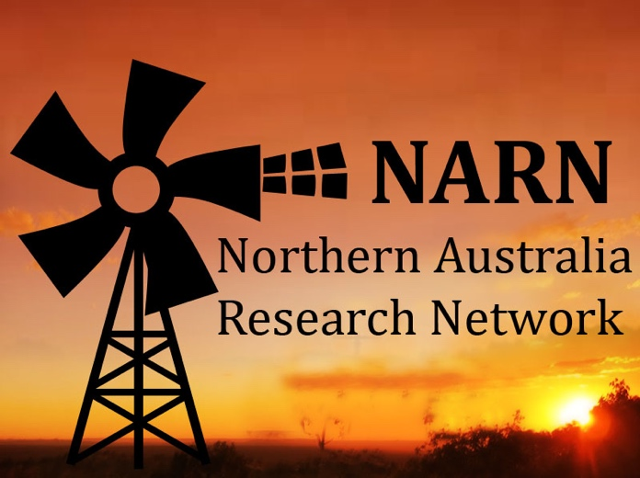 | 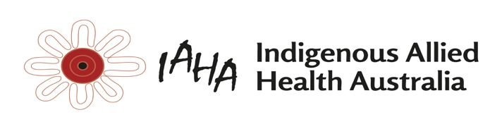

NARN Membership Form
NARN is a collaborative network from WA, NT and Qld that has partnered with IAHA to conduct research to improve the health and wellbeing of people in Northern Australia.

Allied health professionals form most of the NARN membership with a range of other members involved in child development, rehabilitation and older persons’ services.

NARN has a newsletter twice a year – A Dry Season and a Wet Season Newsletter
NARN has an annual forum - the 2020 Forum is to be held in Broome

To become a member
Sign up by email to suzanne.forbes1@jcu.edu.au or in-person at the NARN Forum. ___________________________________________________________________________________
I ……………………………. wish to be a member of the Northern Australia Research Network.
My details are as follows:
Name:
Email:
Phone contact:
Profession:
Place of work:

Welcome aboard!!
Kylie Stothers (IAHA) and Ruth Barker (NARN) Co-Chairs for NARN

